Paradoxes of Material Implication

Whatever would a (rational) man do with himself if not for a logical paradox to worry about? - my own

Predicate Logic is a system of inference that allows us to prove that certain statements are true provided that appropriate conditions hold. In other words, it is a system that embodies the procedures of correct logical reasoning. It allows us to prove theorems based on the existence of axioms. Predicate Logic can be seen as the basis of all correct reasoning, including in mathematics, science, philosophy and daily living.

This paper sets out three paradoxes, all involving logical implication. Note that these paradoxes are generic, in the sense that they can be used as templates to create an indefinite number of similar paradoxes.

The Paradoxes

The discipline of logic can be seen as a set of procedures which allows one to manipulate propositions in such a way that their truth values do not change. A logical paradox occurs when apparently valid procedures are applied to a proposition, causing its truth value to change. One starts with premises that appear to be true and ends up with a conclusion that seems to be palpably false. The paradoxes in this paper conform to this pattern.

1) Washing the Car Makes It Rain

Here is definitive proof that washing your car makes it rain. First some background. Let p and q be two statements and note that ‘~’ means ‘not’. Note that material implication, ie p => q, is defined to mean ~( p & ~q ). It follows that ~( p => q ) is equivalent to ~~( p & ~q ) ie to ( p & ~q ). Now suppose that you have decided to wash your car, rain or shine. Then you can infer that it will rain.

Proof 1.1 Let p be "It will rain" and q be "I will leave my car alone". We know that p => q is not true, so ~(p => q) is true, and p follows due to the equivalence of ~( p => q ) and ( p & ~q ).

Here is another variant of the paradox:

Proof 1.2 that ( x > 1 & x < 1 )
Consider a is “x > 1”, b is “x < 1” and c is “x is 1”, where x ∈ ℜ. We know that a => c is not true, because if a is true then c is false. If we conclude that therefore ~(a => c) is true, then x > 1, as ~(a => c) is equivalent to a&~c. The same logic applied to b => c tells us that b is true, ie x < 1, yielding a contradiction.


Rain-making procedure in NZ

2) The Explosion Paradox

Consider an explosive device. Let 'A' mean "armed", 'F' mean "fired" and 'E' stand for "explodes". Note that ‘V’ is the inclusive 'or' (ie aVb means either a or b, or both are true), '=>' stands for material implication, '<=>' stands for equivalence, ‘&’ stands for “and” (called “conjunction”), and '~' stands for negation. Note that A => E is defined to be ~(A & ~E).

Let p be "(A & F) => E". So p says that if it is armed and fired then it will explode. Let q be "(A => E) V (F => E)". So q says that it will explode if it is armed or it will explode if it is fired (but it is not known which).

Assertion: the statements p and q are equivalent.

Proof 2.1 that q <=> p
(A => E) V (F => E) start with q
<=> ~( ~(A => E) & ~(F => E) ) using the definition of "inclusive or"
<=> ~( ~( ~(A & ~E)) & ~( ~(F & ~E) ) using the definition of material implication
<=> ~( (A & ~E) & (F & ~E) ) double negation cancels out
<=> ~( (A & F & ~E) & ~E ) using the associative law of conjunction
<=> ~( (A & F) & ~E ) using the associative law of conjunction
<=> (A & F) => E using the definition of material implication, giving p

Thus the two statements, p and q, are equivalent, as can be confirmed by the truth table for p and q:

===================================================
A F E (A & F) => E (A => E) V (F => E)
===================================================
T T T T T
T T F F F

T F T T T
T F F T T
F T T T T
F T F T T
F F T T T
F F F T T

Both p and q are true in all but one case, ie when A and F are both true but E is false. We can represent p and q using a Venn diagram, which also confirms their equivalence. The area shown in red is the only case that is ruled out by p being true. It is the same for q.

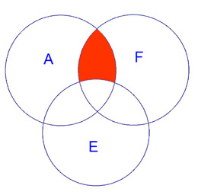
Venn diagram of p, equivalent to the Venn diagram of q

The paradox
Yet p and q are not equivalent. To see this, note that p asserts that both A and F must be simultaneously true for E to logically follow, whereas q says that just one of the two conditions, ie A or F, is by itself enough for E to follow (though we don't know which one). If the device is armed, then disarmed, then fired we get different behaviour in the cases of p and q. In the case of p we cannot be sure that the device will explode, since A and F are not simultaneously true. In the case of q, we see that the device must explode, since it is enough that the device is armed or that it is fired.

In practical terms, p makes sense but q is absurd. A bomb will not explode unless it has been loaded with explosive material and made to go off. If we accept that it is enough just to arm or fire it, but not both, then we are asserting that either (a) the bomb explodes despite being void of explosive materials, or (b) that it will explode spontaneously, of its own accord.

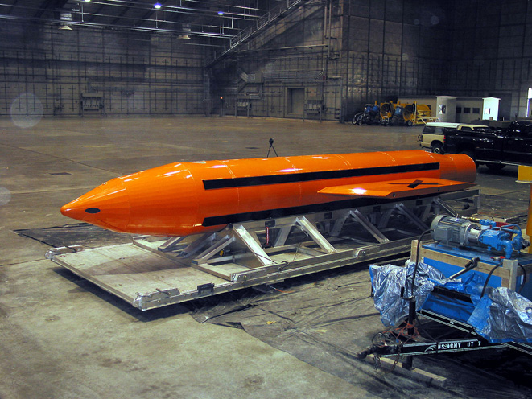
Hopefully, “armed” does not imply it will spontaneously explode!

In case you think that this example is invalid due to changing the truth values of A (arming then disarming) then consider the following example. Let A be “(x > 2)”, F be “(y > 2)” and E be “(x + y > 4)”. Then p is true, but q is false. This is because if both x and y are greater than 2, we know that their sum must be greater than 4, whereas it is not enough for just one of x or y to be greater than 2 for us to know that their sum is greater than 4.

In summary, we have three proofs of the equivalence of p and q, yet the two examples and the real-world meaning of p and q demonstrate that they are not equivalent. Something is badly wrong.

3) Turkey/France Paradox

The following statement is true:
Either if John is in Paris, he is in Turkey; or if John is in Istanbul, he is in France.

Proof 3.1 Let P = "John is in Paris", F = "John is in France", I = "John is in Istanbul" and T = "John is in Turkey". Note that A => B is equivalent to ~AVB (check this using the truth table).

If John is in Paris, he is in France, ie P => F, so we get ~PVF.
If John is in Istanbul, he is in Turkey, ie I => T, so we get ~IVT.

Taking the disjunction (or-ing them together) of these two gives (~PVF) V (~IVT). This is equivalent to "If John is in Paris, he is in France; or if John is in Istanbul, he is in Turkey", a truism.

(~PVF) V (~IVT) <=> (~P) V ( F V (~IVT) ) using associativity of V, ie xV(yVz) = (xVy)Vz
<=> (~P) V (( FV~I) V T ) using associativity of V, ie xV(yVz) = (xVy)Vz
<=> (~PVT) V (FV~I) using associativity of V
<=> (~PVT) V (~IVF) using commutativity of V, ie xVy = yVx
<=> (P => T) V (I => F) using the equivalence of A => B and ~AVB.

So "Either if John is in Paris, he is in Turkey; or if John is in Istanbul, he is in France", an absurdity.

For the associativity and commutativity of the V operator see: Monotone_laws.

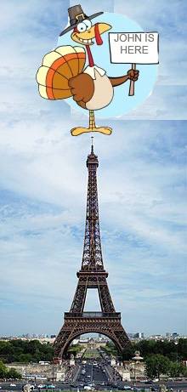
Turkey in Paris

Proposed Solutions

1) Washing the Car Makes It Rain

The answer to this paradox is that if it doesn't rain then p is false and hence p => q is true.

As for proof 1.2, if x = 0, then "If x > 1 then x = 1" is true. This invalidates the proof because a => c can be true, depending on the value of x.

2) The Explosion Paradox

Recall that q was (A => E) V (F => E) and p was (A & F) => E. The argument went like this. A bomb will not explode unless it has been loaded with explosive material and made to go off. If we accept that it is enough just to arm or fire it, but not both, then we are asserting that either (a) the bomb explodes despite being void of explosive materials, or (b) that it will explode spontaneously, of its own accord. So if q is true then the device must go off if it is armed or fired, but this is not the case with p.

This argument is erroneous. If the device is not armed (ie ¬A) then A => E is true, making q true, regardless of whether E is true or not. The same applies to fired. So if q is true and just one of A or F is true then the device need not explode. If q holds the device must explode only if both A and F are true, ie p and q are equivalent.

It was also argued that the example where A is (x > 2), F is (y > 2) and E is (x + y > 4) shows p and q to not be equivalent. To see why this is wrong, consider the four cases:
- x > 2, y > 2: q is true, as x + y > 4
- x > 2, y ≤ 2: q is true, as F is false
- x ≤ 2, y > 2: q is true, as A is false
- x ≤ 2, y ≤ 2: q is true, as both A and F are false.
So both p and q are true in all cases and there is no contradiction.

Why did we mistakenly judge that q means that just one of the two conditions, ie A or F, is by itself enough for E to follow? It was because we were fooled by explosion, ie that a false statement implies every statement, including E.

Thus the explosion paradox is due, appropriately enough, to explosion. It is a variant of the familiar “paradoxes of material implication”, ie intuitive difficulties with logical truisms.

Interestingly, the resolution of this paradox highlights a deficiency of predicate logic. Imagine an electrical circuit (E) with two switches, A and F, one of which operates the circuit, the other being a dummy. This simple scenario cannot be handled using predicate logic, as we have shown that (A => E) V (F => E) does not do the trick. We know that “one of A or F by itself implies E”, yet this simple statement of natural language cannot be expressed in a single truth table, nor in a Venn diagram. Indeed, the quoted sentence cannot be expressed in predicate logic using material implication.

3) Turkey/France Paradox

Consider "Either if John is in Paris, he is in Turkey; or if John is in Istanbul, he is in France". There are only two possible cases:
(a) John is in Istanbul
(b) John is not in Istanbul.
In case (a) “if John is in Paris, he is in Turkey” is true because the conclusion is true.
In case (b) “if John is in Istanbul, he is in France” is true because the premise is false.

So like the explosion paradox, this is not a real paradox. It is merely an intuitively baffling result. Like the others described in the Footnote, it illustrates again that material implication does not capture what we mean in natural language when we say that one statement logically follows from another.

General Conclusion

Material implication does not mirror the intuitive ideas of logical reasoning because it does not capture the meaning of "if... then". The paradoxes of material implication never arise if we interpret p => q as meaning “p is false or q is true”, rather than “p implies q”.

When we apply it in the real world logical implication is rarely true. If we made an arbitrary list of ordinary sentences, each of which is true or false, and chose two of these at random, it is most unlikely that we would see one sentence as logically implying the other. In other words, we see implication as a strong condition, one which is rarely satisfied. By contrast, its negation, ie "does not imply", is very common, like a default condition. That's in the real world. In predicate logic, it is the other way around: p => q is weak because it asserts little, whereas ~( p => q ) is strong, because it makes a definite determination of the truth value of both p and q. The paradoxes arise because we normally use the word “imply” to mean a very strong condition, whereas material implication is very weak.

Intuitively, ~( p => q ) seems like a very weak statement, ie it should be true "almost all the time", because in our thinking about the world, cases where p implies q are rare. Yet in predicate logic, it is strong, ie true in just one case out of four, precisely because its negation, p => q, is itself weak, being false in only one case.

The problem is that we tend to think that "p implies q" means something like "if p is true, then its truth transfers to q, making q also true". So when we look at "p does not imply q" we imagine that no truth is being transferred, ie that nothing happens. Hence we tend to think that ~(p => q) means something like "q does not follow from p", a vague statement that does not mean anything in particular. This notion is wrong, because ~(p => q) is a strong statement, asserting that p is true and q is false.

The paradoxes arise because the strength of implication in predicate logic is the inverse of its strength in normal thought. When we interpret p => q we always need to remember that in addition to the normal meaning of “p implies q” there are two other possibilities. These are the degenerate cases where p is a falsity, or q a truism.

Tad Boniecki
soler@exemail.com.au
January 2013

____________________________________________________________________________________________

Footnote (adapted from wikipedia)

The so-called paradoxes of material implication are a group of formulas which are truths of classical logic, but which are intuitively problematic. The cause of the paradoxes is a mismatch between the interpretation of the validity of logical implication in natural language, and its formal interpretation in classical logic. In classical logic, implication describes conditional if-then statements using a truth-functional interpretation, ie "p implies q" is defined to be "it is not the case that p is true and q false". Also, "p implies q" is equivalent to "p is false or q is true". For example, "if it is raining, then I will bring an umbrella", is equivalent to "it is not raining, or I will bring an umbrella, or both". This truth-functional interpretation of implication is called material implication.
The paradoxes are logical statements which are true but whose truth is intuitively surprising to people who are not familiar with them. If the terms 'p', 'q' and 'r' stand for arbitrary propositions then the main paradoxes are given formally as follows:
- p and its negation imply q.
- If p is false then it implies every q. This is referred to as 'explosion'.
- Either q or its negation is true, so their disjunction is implied by every p.
- If p is true then it is implied by every q.
- If p, q and r are three arbitrary propositions, then either p implies q or q implies r. This is because if q is true then p implies it, and if it is false then q implies any other statement. Since r can be p, it follows that given two arbitrary propositions, one must imply the other, even if they are mutually contradictory. For instance, "Nadia is in Barcelona implies Nadia is in Madrid, or, Nadia is in Madrid implies Nadia is in Barcelona." This truism sounds like nonsense in ordinary discourse.
- If p does not imply q then p is true and q is false. NB if p were false then it would imply q, so p is true. If q were also true then p would imply q, hence q is false. This paradox is particularly surprising because it tells us that if one proposition does not imply another then the first is true and the second false.
These paradoxes arise because of the truth-functional definition of material implication, which is said to be true merely because the antecedent is false or the consequent is true. By this criterion, "If the moon is made of green cheese, then the world is coming to an end," is true merely because the moon isn't made of green cheese. Any contradiction implies anything whatsoever, since a contradiction is never true. Also, any tautology is implied by anything whatsoever, since a tautology is always true.
To sum up, although it is deceptively similar to what we mean by "logically follows" in ordinary usage, material implication does not capture the meaning of "if... then".

